Computer Networks
ASSIGNMENT 1

Name: S. Reema
Register No : 1921260236
Course code: CSA0708
Course:Computer networks

Scenario — Network for a Smart Manufacturing Plant
An automobile-parts company is building a smart plant. Robots on the shop floor must receive control commands within 10 milliseconds; hundreds of sensors report temperature and vibration; CCTV cameras stream video; office staff use the ERP system and e-mail; and the plant exchanges production data with the head office 400 km away.
The contractor proposes ordinary office Wi-Fi throughout the plant and a single broadband connection to the head office. The plant engineers are worried that electrical noise from welding machines will corrupt data, that robot commands will be delayed, and that the head-office link will be too slow.
The network may grow:
1 production line (40 devices) → 1 plant (1,500 devices) → 5 plants connected to the head office
Each task below gives you data from the plant. Use it to calculate, compare and decide – a correct answer must be supported by your working, not only stated.
Design Challenge:
The company plans to use a private 5G network on the shop floor and to connect autonomous guided vehicles (AGVs).
Re-evaluate your original design and determine whether it should be retained, modified or redesigned.

ANSWER – TASK 1: Size the Traffic Before Choosing Anything
Step 1 – Traffic of one production line
Source | Working | Traffic
Robot controllers (40) | 200 B × 8 = 1,600 bit per command. One command every 2 ms = 500 commands/s.  1,600 × 500 = 0.8 Mbps per robot, so 0.8 × 40 | 32 Mbps
Vibration sensors (600) | 50 B/s × 8 = 400 bps per sensor; 400 × 600 = 240,000 bps | 0.24 Mbps
CCTV cameras (24) | 24 × 4 Mbps, continuous | 96 Mbps
Office users (150) | 10% active at a time = 15 users; 15 × 2 Mbps | 30 Mbps
Total, one line | 32 + 0.24 + 96 + 30 | 158.24 Mbps
Plant, 8 lines | 158.24 × 8 | 1,265.92 Mbps (≈ 1.27 Gbps)

These are payload figures only. With Ethernet/IP/TCP headers (Task 3: 58 extra bytes on every 200-byte command) the robot traffic is really about 41 Mbps instead of 32 Mbps, so the real load is a little higher than shown.
Step 2 – Biggest sender and strictest delay
The source that sends the most data is the CCTV cameras: 96 of 158.24 Mbps, which is 60.7% of the line (robots 20.2%, office 19.0%, sensors 0.2%). The source with the strictest delay requirement is the robot controllers (10 ms deadline, one command every 2 ms). So the two are not the same. The heaviest traffic is the one that can wait, and the most delay-sensitive traffic is only a fifth of the volume. This is the main reason why volume alone must not decide the design.
Step 3 – Is a single 1 Gbps uplink enough?
- One line: 158.24 Mbps is 15.8% of 1 Gbps, so it is fine.
- Whole plant (8 lines): 1,265.92 Mbps is 126.6% of 1 Gbps, so the offered load is more than the link can carry. Even before 100%, queues grow quickly above roughly 70–80% utilisation, so one gigabit really supports only about 4–5 lines. A 10 Gbps uplink (or several 1 Gbps links) is needed.
- Robot commands sharing one queue with CCTV: in a normal FIFO queue a robot packet waits behind the video packets that arrived before it. If 24 cameras burst together, 24 × 1,500 B = 288,000 bit, which takes 0.288 ms at 1 Gbps. This is harmless for one line. When the uplink is overloaded the queue stays full: with a 1 MB (8 Mbit) buffer a command can wait up to 8 Mbit / 1 Gbps = 8 ms, which is already 80% of the 10 ms budget, and when the buffer overflows the command is dropped and must be retransmitted (TCP timeout of 200 ms or more). The fix is to put robots in their own VLAN with a strict-priority queue (802.1p) or on a separate link from CCTV.
Step 4 – Ranking by harm of a 100 ms delay, and delay-versus-volume comparison
Rank | Traffic | Volume (Mbps, % of line) | Delay it can tolerate | What a 100 ms delay does
1 | Robot commands | 32 (20.2%) | 10 ms | 10 times the deadline; about 50 commands (100 ms / 2 ms) are late. The robot acts on old data, which can cause a collision, a safety stop or scrapped parts.
2 | CCTV video | 96 (60.7%) | about 200–300 ms | Live picture and motion alarms lag by 0.1 s, which is noticeable but acceptable. Jitter and loss hurt video more than fixed delay.
3 | Office / ERP / e-mail | 30 (19.0%) | about 150–500 ms | Interactive but not real-time; users may notice a slow click, but no transaction fails.
4 | Vibration sensors | 0.24 (0.2%) | seconds | A reading is sent every second, so 100 ms is only 10% of the period; trend analysis is unaffected.

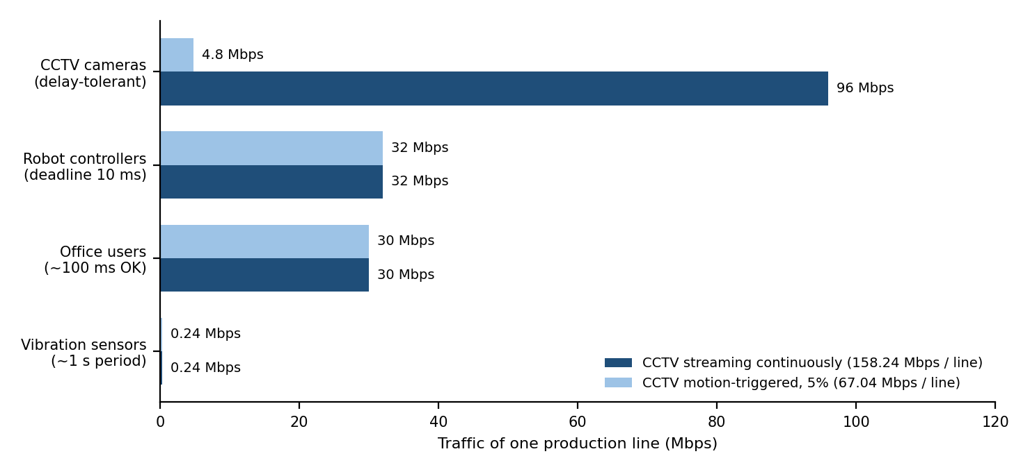
Figure 1 – Traffic per source on one line against how much delay each can tolerate (dark bars: continuous CCTV; light bars: motion-triggered CCTV)
Alternative Concept Analysis – motion-triggered CCTV
If the cameras record locally and send clips only 5% of the time, the CCTV traffic becomes 96 × 0.05 = 4.8 Mbps.
New line traffic = 32 + 0.24 + 4.8 + 30 = 67.04 Mbps
New plant traffic (8 lines) = 67.04 × 8 = 536.32 Mbps = 53.6% of 1 Gbps
The load falls by 57.6% (from 1,265.92 to 536.32 Mbps), so the 1 Gbps uplink is no longer overloaded and is not the bottleneck any more. The biggest sender now becomes the robot controllers (32 Mbps, 47.7% of the line), which is the traffic that needs the priority treatment anyway. Two points to keep in mind: (1) 53.6% average load leaves little room for growth to 1,500 devices or 5 plants, so I would still plan a 10 Gbps backbone; (2) local recording needs storage: 24 cameras × 4 Mbps is about 1 TB per day per line, and motion events happen together (a fault on the line triggers many cameras), so short bursts back up to 96 Mbps and QoS is still needed.

ANSWER – TASK 2: Count the Domains in the Contractor’s Drawing
Marked drawing and domain count
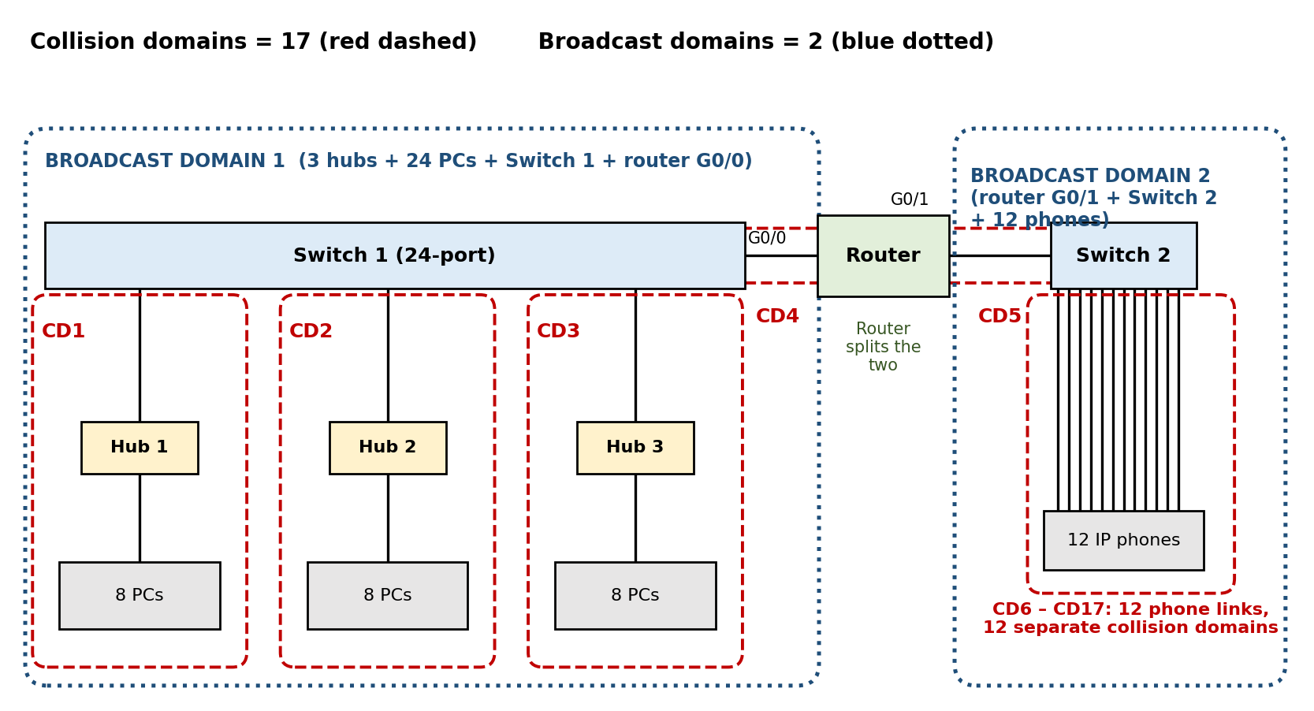
Figure 2 – Contractor’s office drawing with collision domains (red) and broadcast domains (blue) marked
Part of the drawing | Collision domains | Reason
Hub 1 + its 8 PCs + hub-to-switch link | 1 | A hub repeats every signal to all ports, so all 8 PCs and the switch port share one collision domain.
Hub 2 + 8 PCs | 1 | Same reason.
Hub 3 + 8 PCs | 1 | Same reason.
Switch 1 port – router G0/0 link | 1 | Switch ports and router interfaces each end a collision domain.
Router G0/1 – Switch 2 link | 1 | Same.
12 IP phones, one cable each to Switch 2 | 12 | Every switch port is its own collision domain.
Total | 17

Broadcast domains = 2. Hubs and switches pass broadcasts to every port, so Hub 1–3, Switch 1 and router interface G0/0 form broadcast domain 1; a router does not forward broadcasts, so G0/1, Switch 2 and the 12 phones form broadcast domain 2.
OSI layer of each device and why a hub cannot stop collisions
Device | OSI layer | Why
Hub | Layer 1 – Physical | It only regenerates and repeats the electrical signal; it does not read addresses.
Switch | Layer 2 – Data link | It reads the destination MAC address and forwards the frame only to the right port using its MAC table.
Router | Layer 3 – Network | It forwards packets using the destination IP address and separates broadcast domains.
PC and IP phone | All layers (1–7) | They are end systems; the application runs here.

A hub cannot stop collisions because it has no memory or intelligence: it does not look at frames, cannot store them, and simply copies whatever arrives on one port to all other ports. If two PCs transmit at the same time the signals overlap on the hub, and every device sees the collision. The PCs must therefore use half-duplex CSMA/CD, and the 8 PCs on one hub share one 100 Mbps link (about 12.5 Mbps each if all are busy).
Point-to-point and multipoint connections
- Point-to-point: Hub-to-switch, switch-to-router G0/0, router G0/1-to-Switch 2, and every IP phone-to-Switch 2 cable. Each of these cables joins exactly two devices.
- Multipoint (shared): Each hub segment. Physically every PC has its own cable to the hub, but logically the 8 PCs and the uplink share one medium, like a bus. A Wi-Fi cell would also be multipoint.
Standards table
Technology | Standard | Defined by | What it defines
Ethernet | IEEE 802.3 | IEEE | Frame format, MAC method (CSMA/CD) and physical layers for wired LANs
Wi-Fi | IEEE 802.11 | IEEE (the Wi-Fi Alliance certifies products) | Wireless LAN MAC (CSMA/CA) and radio layers
IPv4 | RFC 791 | IETF | 32-bit addressing, packet header, fragmentation
OSI model | ISO 7498 | ISO | The 7-layer reference model
5G | 3GPP Release 15 onwards / IMT-2020 | 3GPP and ITU | 5G New Radio, core network and service types (eMBB, URLLC, mMTC)

The plant should buy only standard-compliant equipment because (1) devices from different vendors (robot controller, switch, camera, router) must work together; (2) it avoids lock-in, so a failed or obsolete part can be replaced by another brand; (3) the network will grow from one line to five plants and new equipment must still join the old one; (4) standard products are tested, documented and cheaper because of competition, and security patches and trained engineers are easier to find.
Alternative Concept Analysis – replace the three hubs by three unmanaged switches
Collision domains = 24 PC links + 3 switch uplinks + 1 (G0/0 link) + 1 (G0/1 link) + 12 phone links = 41
Broadcast domains = 2 (unchanged, because switches do not split broadcast domains)
This change fixes | This change does not fix
Collisions disappear; the links can run full duplex, so CSMA/CD is not needed.  Each PC gets its own 100 Mbps instead of sharing one hub (about 12.5 Mbps).  Frames go only to the correct port, which also gives some privacy. | The 24 PCs are still in one broadcast domain (ARP and other broadcasts reach all of them).  Unmanaged switches have no VLANs, QoS, port security or monitoring (SNMP), so robots cannot be given priority.  No loop protection, and one switch or uplink is still a single point of failure.

ANSWER – TASK 3: Read a Captured Frame Layer by Layer
Layer and PDU of each line of the capture
Line of the capture | Key fields | OSI layer | PDU
Ethernet II | Src/Dst MAC, Type 0x0800 (next header is IPv4) | Layer 2 – Data link | Frame
IPv4 | 10.10.1.25 → 10.10.9.4, TTL 61, Protocol 6 (TCP) | Layer 3 – Network | Packet
TCP | Port 51522 → 502, Seq 1201, Ack 88, Len 12 | Layer 4 – Transport | Segment
Data (Modbus write-register) | 12 bytes of command | Layer 7 – Application | Data / message

Each field tells the receiver what to do next: Type 0x0800 says “hand this to IPv4”, Protocol 6 says “hand this to TCP”, and destination port 502 says “give it to the Modbus application”.
Routers crossed
The controller starts with TTL = 64 and the captured packet has TTL = 61.
Each router subtracts 1, so routers crossed = 64 − 61 = 3
Bytes on the wire and overhead
Item | 12-byte robot command | 1,400-byte camera packet
Data | 12 B | 1,400 B
TCP header | 20 B | 20 B
IPv4 header | 20 B | 20 B
Ethernet header (14) + FCS (4) | 18 B | 18 B
Total on the wire | 70 B | 1,458 B
Overhead (58 B) | 58 / 70 = 82.9% | 58 / 1,458 = 4.0%

for a small command, 83% of the bits sent are headers and only 17% is useful data, while for a large camera packet the headers are only 4%. Small control messages are therefore very inefficient in bandwidth, but this does not matter much for robots because the volume is small (Task 1); what matters is the delay and the number of packets. (The preamble and inter-frame gap add another 20 bytes on the line, so the real link occupancy is 90 B per command.)
Which layer is responsible?
Fault | Layer | What happens
(a) MAC address is wrong | Layer 2 – Data link | The NIC or switch does not accept or deliver the frame because the destination MAC does not match; the frame is discarded or flooded.
(b) TTL reaches 0 | Layer 3 – Network | The router discards the packet and sends an ICMP “Time Exceeded” message (this also stops routing loops).
(c) Destination port is closed | Layer 4 – Transport | No program is listening on port 502, so the host replies with a TCP reset (RST).

TCP/IP model mapped to the seven OSI layers
TCP/IP layer | OSI layers | Examples
Application | 7 Application, 6 Presentation, 5 Session | Modbus, HTTP, DNS
Transport | 4 Transport | TCP, UDP
Internet | 3 Network | IP, ICMP, routers
Network access (link) | 2 Data link, 1 Physical | Ethernet, Wi-Fi, cables, NIC

Complete the Code – TODO 1 (saved as Task03/layers.py)
def send(message):
pdu = message
for layer, tag in LAYERS:
# TODO 1 (completed)
if tag == "ETH":
pdu = "[" + tag + "|" + pdu + "|FCS]" # header and trailer
else:
pdu = "[" + tag + "|" + pdu + "]" # header only
print(f"{layer} adds {tag} -> {len(pdu)} bytes")
return pdu

Output of my run (it is the same as the expected output):
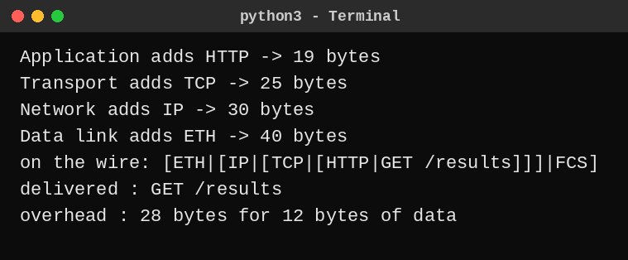

1,400-byte message: I changed the message to 1,400 characters and ran it again. The frame is 1,428 bytes and the overhead is still 28 bytes, which is 1.96%, compared with 28 / 40 = 70% for the 12-byte message. The overhead in bytes is fixed, so it is large only for tiny messages.
Alternative Concept Analysis – raw Ethernet (EtherType 0x8892) without IP and TCP
Removing the IP (20 B) and TCP (20 B) headers takes away 40 bytes of header from every command. But an Ethernet frame must carry at least 46 bytes of payload, so the 12-byte command is padded and the frame cannot go below the 64-byte minimum. The saving on the wire is therefore smaller than 40 bytes:
 | Ethernet + IP + TCP | Raw Ethernet (0x8892)
Frame size per command | 70 B | 64 B (padded to the minimum)
Bytes saved per command | – | 6 B on the wire (40 B of headers removed, 34 B become padding)
Commands per second on 100 Mbps (frame only) | 100 × 10⁶ / (70 × 8) = 178,571 | 100 × 10⁶ / (64 × 8) = 195,313
Same, counting 20 B preamble + gap | 100 × 10⁶ / (90 × 8) = 138,889 | 100 × 10⁶ / (84 × 8) = 148,810
Extra commands per second freed | – | +16,742 (+9.4%); +9,921 (+7.1%) with preamble

What the plant loses by giving up IP: (1) routing, because the frames stay inside one layer-2 network and cannot cross a router to another line, plant or the head office; (2) TCP’s reliability, with no sequence numbers, retransmission or flow control, so the application or the real-time protocol must handle loss; (3) IP addressing, firewall rules and IPsec security; (4) TTL protection against loops. The gain is lower and more predictable latency. My decision: use raw Ethernet only inside a robot cell and use IP for everything that has to leave the cell

ANSWER – TASK 4: Choose a Medium for Each Run
Medium chosen for each run
Run | Distance | Medium chosen | Deciding reason
(a) Robot cell next to arc-welding machines | 85 m | Cat6A S/FTP (shielded copper) | Within the 100 m copper limit, and the foil and braid shield rejects the electrical noise of the welders. Fibre is the fallback if the noise is still too high.
(b) Office floor to shop-floor switch | 140 m | Multimode fibre (OM3) | The trap: it looks like an ordinary office cable, but 140 m is more than the 100 m channel limit of UTP. Fibre also isolates the office from welding noise and ground-potential differences.
(c) Shop floor to data centre | 550 m | Single-mode fibre (OS2) | Multimode would reach 550 m only at 1 Gbps. The plant needs more than 1 Gbps (1.27 Gbps, Task 1), so 10 Gbps is needed, and 10G over multimode reaches only 300–400 m.
(d) Plant to head office | 400 km | Leased line (carrier fibre with an SLA) | No private cable is possible over 400 km. A leased line gives a fixed bandwidth and delay; ordinary broadband is shared (see Task 10).

Which run cannot use copper at all? Run (d). Copper Ethernet is limited to 100 m, so 400 km would need about 400,000 / 100 = 4,000 repeater segments, which is impossible in practice. Runs (b) and (c) also exceed 100 m and cannot use a single copper cable (a switch halfway could be used for (b), but fibre is cleaner). Run (b) is the trap because it is the one that looks short enough for copper.
Shannon capacity of the 250 MHz cable
SNR = 40 dB → ratio = 10^(40/10) = 10,000; C = 250 × 10⁶ × log₂(1 + 10,000) = 250 × 10⁶ × 13.29 = 3,322 Mbps
SNR = 15 dB → ratio = 10^(15/10) = 31.62; C = 250 × 10⁶ × log₂(1 + 31.62) = 250 × 10⁶ × 5.03 = 1,257 Mbps
The noise near the welders reduces the theoretical capacity by 62% (3,322 → 1,257 Mbps). For the robot cell this does not mean that the cable is too slow: a robot needs only 0.8 Mbps (Task 1), more than 1,500 times less than 1,257 Mbps. The real danger is that a low SNR raises the bit-error rate, so more frames fail the CRC and are dropped and retransmitted, and the 10 ms deadline is missed. That is why the cable near the welders must be shielded and grounded, so that the 40 dB value is kept.
Why measured speed is always below the Shannon limit: Shannon is a theoretical maximum that needs ideal coding and perfect equipment. Real links use practical modulation and coding, suffer attenuation, crosstalk and impulse noise that is not simple white noise, and lose bandwidth to headers, preamble, gaps and retransmissions (Task 3 showed 58 bytes of header per frame).
Complete the Code – TODO 1 and TODO 2 (saved as Task04/limits.py)
def nyquist(bandwidth_hz, levels):
# TODO 1 (completed)
return 2 * bandwidth_hz * math.log2(levels)

def shannon(bandwidth_hz, snr_db):
# TODO 2 (completed)
snr = 10 ** (snr_db / 10)
return bandwidth_hz * math.log2(1 + snr)

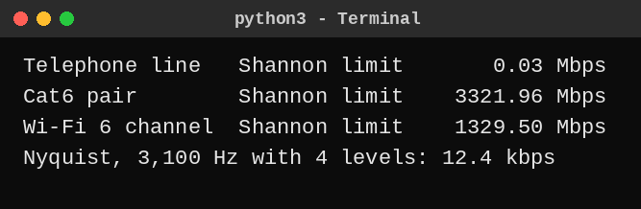

The output matches the expected output. SNR needed for 56 kbps on a 3,100 Hz line: from C = B log₂(1 + SNR), 1 + SNR = 2^(56,000 / 3,100) = 2^18.06, so SNR = 274,132, which is 10 log₁₀(274,132) = 54.4 dB. This is not realistic for an analogue telephone line, which typically gives 30–35 dB (30 dB gives only about 31 kbps, as the program shows). The old 56k modems worked only because the signal was digital for most of the path, so they were not limited by this analogue calculation.
Alternative Concept Analysis – Wi-Fi 6 in the robot cell
C = 160 × 10⁶ × log₂(1 + 31.62) = 160 × 10⁶ × 5.03 = 804 Mbps at 15 dB
Capacity is again not the problem (a robot needs 0.8 Mbps). The problem is the 10 ms deadline. Wi-Fi uses CSMA/CA with random back-off, so a command may wait while other stations or neighbouring access points use the channel; welding noise lowers the SNR, so the radio falls back to a slower rate or retries, and the delay becomes variable (jitter). Wi-Fi gives good average latency but no guaranteed maximum. Decision: a wireless link is not acceptable for the 10 ms robot commands; keep the shielded cable (Cat6A S/FTP, 40 dB, 3,322 Mbps capacity) for the fixed robots and use Wi-Fi only for non-critical devices such as tablets.

ANSWER – TASK 5: Wi-Fi 6 or 5G for Moving Equipment?
Hand-over calculation
Trip time = 1,200 m / 2 m/s = 600 s
Wi-Fi: cells = 1,200 / 30 = 40, so hand-overs = 40 − 1 = 39 (one every 30 / 2 = 15 s)
5G: cells = 1,200 / 300 = 4, so hand-overs = 4 − 1 = 3 (one every 150 s)
 | Wi-Fi 6 | Private 5G
Hand-overs per trip | 39 | 3
Time per hand-over | 150 ms | 20 ms
Total time not reachable per trip | 39 × 150 ms = 5.85 s (0.98% of the trip) | 3 × 20 ms = 0.06 s (0.01% of the trip)
10 ms commands missed per trip | 39 × 15 = 585 | 3 × 2 = 6

5G is about 97.5 times better (5,850 ms / 60 ms) for the time during which the AGV cannot be reached. Even so, 20 ms is still longer than the 10 ms deadline, so each 5G hand-over would still miss 2 commands unless dual connectivity or make-before-break hand-over is used.
5G service type for each device
Device | 5G service | Reason
AGVs (and robots) | URLLC (ultra-reliable low-latency) | Small commands with a 10 ms deadline and a need for very high reliability (never miss a command).
CCTV cameras | eMBB (enhanced mobile broadband) | High bandwidth: 24 × 4 Mbps = 96 Mbps per line, mostly uplink video.
Sensors | mMTC (massive machine-type communication) | Very many devices (600 per line, 4,800 per plant) sending tiny 50-byte messages, with low power use.

Where Bluetooth, Zigbee or LoRa is the better choice
- Bluetooth Low Energy (range about 10–50 m, low power): pairing a technician’s tablet or scanner with a machine, worker and tool tracking tags, wireless headsets, and asset tags inside one cell. Wi-Fi or 5G would use too much power and is too complex for these.
- Zigbee (about 10–100 m, 250 kbps, mesh): many small battery sensors and actuators across the building, such as lighting, air-conditioning, door and temperature sensors, where mesh networking extends the range.
- LoRa (kilometres of range, only a few kbps): slow outdoor or far-away measurements, such as the yard, water tanks, energy meters and temperature readings every few minutes, running on a battery for years.
Can Wi-Fi 6 with fast roaming (802.11r) meet the deadline?
802.11r skips the full re-authentication during roaming, so the hand-over drops from about 150 ms to roughly 50 ms or less (it depends on the vendor). Even at 50 ms, the AGV is unreachable for 39 × 50 ms = 1.95 s per trip and misses about 5 commands at each hand-over, which is still more than the 10 ms deadline allows. Wi-Fi 6 may reach a few milliseconds on average, but what remains risky is: (1) CSMA/CA contention and random back-off, which give no guaranteed maximum delay; (2) interference from welding and nearby access points; (3) the AGV decides when to roam, so it may stick to a weak access point or bounce between two (ping-pong); (4) all access points and AGV radios must support 802.11r/k/v. So Wi-Fi 6 with 802.11r meets 10 ms on average but cannot guarantee it.
Alternative Concept Analysis – LoRaWAN for the sensors
Offered load = 600 sensors × 50 B/s × 8 = 240,000 bps = 240 kbps
Gateway capacity ≈ 5 kbps, so the load is 240 / 5 = 48 times more than the gateway can carry
Share per sensor = 5,000 / 600 = 8.3 bps, about 1 byte per second (only about 5,000 / 400 = 12 sensors could send 50 B/s)
So the 600 sensors do not fit on one LoRa gateway. If a sensor sent its 50 bytes only once a minute (400 bit / 60 s = 6.7 bps each), 600 sensors would need 4 kbps (80% of the gateway), which would fit but with little spare capacity. Decision: the vibration sensors that report 50 B every second stay on Wi-Fi 6 (or 5G mMTC); the slow temperature sensors, which need to report only once a minute or less, and the battery-powered sensors far from the building, are moved to LoRaWAN.

ANSWER – TASK 6: Interpret an Ethernet Port Report
Meaning of the errors
- Late collision: a collision detected after the first 64 bytes (512 bit-times) of a frame have been sent. On a correct half-duplex link every collision happens inside that window, so a late collision means that the other end was transmitting without waiting, or that the cable is too long.
- CRC error: the frame arrived, but the FCS calculated by the receiver does not match the FCS in the frame, so the frame is damaged (noise, a bad cable, or a frame cut short by a collision).
- Together: 412 late collisions + 1,907 CRC errors = 2,319 of the 2,381 rx_errors (97%). Late collisions together with CRC errors on a port running half duplex are the typical signature of a duplex mismatch: one end is full duplex and sends at any time, and the half-duplex end (this PC) sees it as a collision late in the frame, so the frame is cut and fails the CRC. TCP then has to retransmit, which is why the PC feels slow.
Likely cause and the configuration change
The PC has auto-negotiation turned off and is forced to 100 Mb/s half duplex, while the gigabit switch port is on auto. The switch cannot read the PC’s duplex setting, so the two ends disagree. Gigabit Ethernet (1000BASE-T) also requires auto-negotiation to be on. The rule is that both ends must be on auto, or both fixed to the same values.
Linux (ethtool):
sudo ethtool eth0 # check: Speed 100Mb/s, Duplex Half, Auto-negotiation off
sudo ethtool -s eth0 autoneg on # turn auto-negotiation back on
# or: sudo ethtool -s eth0 speed 1000 duplex full autoneg on
sudo ethtool eth0 # verify: 1000Mb/s, Full, Auto-negotiation on
ethtool -S eth0 | grep -E "crc|collision" # counters should stop increasing

Windows: Device Manager → Network adapters → the adapter → Properties → Advanced → Speed & Duplex → choose Auto Negotiation; or in PowerShell: Set-NetAdapterAdvancedProperty -Name "Ethernet" -DisplayName "Speed & Duplex" -DisplayValue "Auto Negotiation".
MAC addresses
- 01:00:5e:0a:01:02 – the first byte 0x01 = 00000001 has its least-significant bit set to 1, so it is a group (multicast) address, not a single device. The prefix 01:00:5e is the range used for IPv4 multicast; the last 23 bits (0a:01:02) come from the multicast IP address, so it corresponds to groups such as 224.10.1.2 or 239.10.1.2.
- 3c:52:82:4e:11:07 – the first three bytes 3c:52:82 are the OUI (Organisationally Unique Identifier) assigned by the IEEE to the NIC manufacturer, and the last three bytes (4e:11:07) are the serial number given by that manufacturer. The first byte 0x3c = 00111100 has its two lowest bits 0, so it is a unicast, globally unique (burned-in) address. The vendor name can be looked up in the IEEE OUI registry.
Would jumbo frames help the CCTV storage server?
Yes, for the server side. With 1,400-byte packets the header overhead is 4.0% (Task 3), and with 9,000-byte frames it is 58 / 9,058 = 0.64%. For 768 Mbps of CCTV (8 lines, continuous) the server would handle 768 × 10⁶ / (1,400 × 8) = 68,571 frames per second, against 768 × 10⁶ / (9,000 × 8) = 10,667 frames per second with jumbo frames, so the CPU and interrupt load is about 6 times lower. What must also change: every device on the path must support the same large MTU: the server NIC, the recorder, every switch port in between (jumbo frames enabled, for example MTU 9000), and any router interface in that VLAN, otherwise the frames are dropped or fragmented. The cameras themselves send packets of about 1,400 bytes, so the benefit is on the storage path. I would use a separate storage VLAN at 1 or 10 Gbps (a 9,000 B frame takes 72 µs at 1 Gbps, but 0.72 ms at 100 Mbps, which is too long for the robot traffic).
Alternative Concept Analysis – ring of industrial switches versus star
 | Ring with fast ring recovery | Star of switches
Recovery time after one cable cut | Automatic: about 200 ms with MRP, 10–30 ms with fast profiles, 1–2 s with RSTP; zero with PRP/HSR | None: the spoke stays down until the cable is repaired (minutes to hours)
Devices that lose connection | None permanently; traffic crossing the cut is interrupted only during recovery | All devices behind the cut link (for example a whole line switch with 40 devices)
Other points | Longest path up to N/2 switches; the loop must be controlled by the ring protocol | Faults stay local to one spoke, but the central switch is a single point of failure

For the 10 ms robot deadline even a 200 ms recovery means that about 20 commands are lost, so for the robot cells I would use a ring with the fastest recovery profile or a zero-recovery method such as PRP/HSR, and a star is acceptable for CCTV and office switches where a few minutes of outage is tolerable.

ANSWER – TASK 7: Will the Receiver Notice the Error?
CRC of 1101011011 with generator 1011 (x³ + x + 1), by hand
The generator has 4 bits, so the CRC has 3 bits. I append three zeros to the data: 1101011011000. Then I divide by 1011 using XOR (no borrowing). Whenever the leading bit is 1 I XOR the generator into the next four bits; when it is 0 I move one bit to the right.
Step | 4 bits at the leading 1 | XOR 1011 | Whole string after the step
Start |  |  | 1101011011000
1 | 1101 | 0110 | 0110011011000
2 | 1100 | 0111 | 0011111011000
3 | 1111 | 0100 | 0001001011000
4 | 1001 | 0010 | 0000010011000
5 | 1001 | 0010 | 0000000101000
6 | 1010 | 0001 | 0000000000100

Remainder (last 3 bits) = 100, so the CRC is 100 and the transmitted frame is 1101011011100.
Is the received frame 1101011011101 accepted?
I divide the whole received frame by 1011. The remainder is 001, which is not 000, so the frame is rejected. (It differs from the transmitted frame 1101011011100 in the last bit: the error pattern is 0000000000001.)
Burst errors and an undetectable pattern
A CRC with an r-bit check (here r = 3) detects every burst error of length up to 3 bits; a burst of length 4 is missed with probability 2^−(r−1) = 25%, and longer bursts with probability 2^−r = 12.5%. An error the generator cannot detect is any pattern that is an exact multiple of the generator, for example the generator itself, 1011 (flipping three bits of the frame gives remainder 0), or two flipped bits 7 positions apart (x⁷ + 1 is divisible by x³ + x + 1).
Two-dimensional parity of a 4 × 4 block
 | c1 | c2 | c3 | c4 | Row parity
r1 | 1 | 0 | 1 | 1 | 1
r2 | 0 | 1 | 1 | 0 | 0
r3 | 1 | 1 | 0 | 0 | 0
r4 | 0 | 1 | 0 | 1 | 0
Column parity | 0 | 1 | 0 | 0 | 1

(Even parity: each row and column, with its parity bit, has an even number of 1s.) A 4-bit error that it misses: flip the four bits at the corners of a rectangle, for example r1c1, r1c2, r2c1 and r2c2. Every row and every column then has two changed bits, so every parity is still even and the receiver accepts the block although four bits are wrong.
Internet checksum of 4500, 0073, 0000, 4000 (hex)
4500 + 0073 = 4573; 4573 + 0000 = 4573; 4573 + 4000 = 8573 (no carry out of 16 bits)
One’s complement of 8573 = FFFF − 8573 = 7A8C
Check: 8573 + 7A8C = FFFF, so the receiver’s sum is all ones and the data is accepted.
Complete the Code – TODO 1 (saved as Task07/crc.py)
def mod2_div(dividend, divisor):
rem = list(dividend)
for i in range(len(dividend) - len(divisor) + 1):
# TODO 1 (completed)
if rem[i] == "1":
for j in range(len(divisor)):
rem[i + j] = "0" if rem[i + j] == divisor[j] else "1" # XOR
return "".join(rem[-(len(divisor) - 1):])

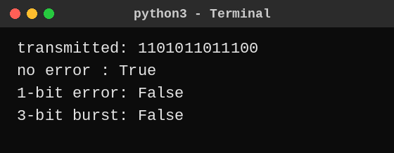

The output matches the expected output. Finding an undetected error with the program: I tried every pattern of 1 to 4 flipped bits on the 13-bit frame. The program found 145 patterns that are not detected, and none of them was a 1-bit error or a burst of up to 3 bits. One example is the pattern 1000000100000 (two bits 7 apart), which turns the frame into 0101011111100, and check() still returns True. The reason is that this error polynomial is x⁵(x⁷ + 1), and x⁷ + 1 = (x + 1)(x³ + x + 1)(x³ + x² + 1) is divisible by the generator, so the remainder is zero. The generator itself (0000000001011) is also accepted.
Alternative Concept Analysis – even parity bit versus CRC-3 (1011)
Method | 2-bit error | Result | 4-bit error | Result
Even parity (1 check bit) | 0000000000011 | Missed (even number of flips) | 0000000001111 | Missed
CRC-3 (1011) | 0000000000011  1000000100000 | Caught  Missed (7 apart) | 0000000001111  0000000011101 | Caught  Missed (multiple of 1011)

- Parity catches but CRC-3 misses: odd-weight errors that are multiples of the generator, for example the 3-bit pattern 0000000001011 (parity sees an odd number of flips and rejects it, but the CRC remainder is 0). Because 1011 has three terms, it is not divisible by (x + 1), so it does not guarantee detection of all odd errors.
- CRC-3 catches but parity misses: every 2-bit error that is not 7 apart, such as 0000000000011, and 4-bit bursts such as 1111, because parity only counts whether the number of flipped bits is odd.
- Strength: parity (1 check bit) detects all odd-numbered errors but no even-numbered ones; CRC-3 (3 check bits) detects all 1-bit errors, all bursts up to 3 bits and most longer errors. Real Ethernet therefore uses a 32-bit CRC, which misses only about 1 in 2³² random errors.

ANSWER – TASK 8: Correct the Error or Ask Again?
Hamming check bits for a 16-bit word
Condition: 2^r ≥ m + r + 1 with m = 16
r = 4: 16 ≥ 16 + 4 + 1 = 21? No. r = 5: 32 ≥ 22? Yes, so r = 5 check bits
Codeword = 16 + 5 = 21 bits; overhead = 5 / 16 = 31.25% of the data (5 / 21 = 23.8% of the bits sent)
Minimum Hamming distance of {00000, 01011, 10101, 11110}
Pair | XOR | Distance
00000 – 01011 | 01011 | 3
00000 – 10101 | 10101 | 3
00000 – 11110 | 11110 | 4
01011 – 10101 | 11110 | 4
01011 – 11110 | 10101 | 3
10101 – 11110 | 01011 | 3

The minimum distance is d = 3. The code can detect d − 1 = 2 errors and correct ⌊(d − 1) / 2⌋ = 1 error.
Hamming(7,4): 0110011 received as 0110111
Received bits at positions 1 to 7: 0 1 1 0 1 1 1.
s1 = c1 ⊕ c3 ⊕ c5 ⊕ c7 = 0 ⊕ 1 ⊕ 1 ⊕ 1 = 1
s2 = c2 ⊕ c3 ⊕ c6 ⊕ c7 = 1 ⊕ 1 ⊕ 1 ⊕ 1 = 0
s3 = c4 ⊕ c5 ⊕ c6 ⊕ c7 = 0 ⊕ 1 ⊕ 1 ⊕ 1 = 1
Error position = s1 + 2·s2 + 4·s3 = 1 + 0 + 4 = 5. Flip bit 5: the corrected codeword is 0110011, and the data bits (positions 3, 5, 6, 7) are 1011.
FEC or ARQ for the vibration sensor link?
The sensors send a short 16-bit reading over a noisy radio link where one retransmission costs 40 ms. I choose forward error correction (FEC) for this link: the receiver repairs a single-bit error immediately, the delay is constant, and a battery sensor does not have to stay awake to wait for an acknowledgement. ARQ would add 40 ms (or more) to every damaged reading and needs a return path. (ARQ remains the better choice on the clean wired links, where errors are rare and retransmission is cheap.) Video streaming and 5G use FEC because they are real-time: a retransmitted video frame would arrive after its play-out time and be useless, broadcast or multicast video has many receivers, and the 5G radio has a high error rate and a latency budget of only 1–10 ms, so it uses strong codes (LDPC and Polar) and only a very fast HARQ on top.
Complete the Code – TODO 1 (saved as Task08/hamming.py)
def decode(c):
# TODO 1 (completed)
c = c[:]
s1 = c[0] ^ c[2] ^ c[4] ^ c[6] # positions 1,3,5,7
s2 = c[1] ^ c[2] ^ c[5] ^ c[6] # positions 2,3,6,7
s3 = c[3] ^ c[4] ^ c[5] ^ c[6] # positions 4,5,6,7
pos = s1 + 2 * s2 + 4 * s3
if pos != 0:
c[pos - 1] ^= 1 # flip the wrong bit
return pos, [c[2], c[4], c[5], c[6]]

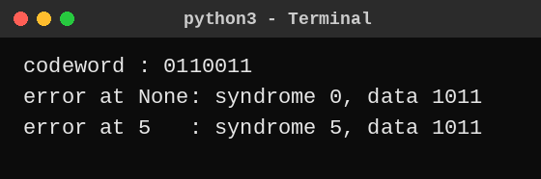

This is the same as the expected output. Two-bit error: I flipped positions 3 and 5 of the codeword. The received word is 0100111, the syndrome is 3 ⊕ 5 = 6, so the decoder flips bit 6, which was correct, and returns data 0101 instead of 1011. It gives no warning. A code with distance 3 can only fix one error; with two errors it “corrects” the wrong bit. An extra overall parity bit (SECDED) is needed to at least detect the double error.
Alternative Concept Analysis – Hamming FEC versus retransmission at BER = 1 in 1,000
P(a 16-bit reading has an error) = 1 − 0.999¹⁶ = 0.0159 (1.59%)
 | Retransmit on error (ARQ) | Hamming(21,16) correction
Bits sent per reading | 16 / (1 − 0.0159) = 16.26 bits on average (error-detection bits and ACK ignored) | 21 bits every time (+29% compared with ARQ)
Chance of needing a resend | 1.59% of the readings | P(2 or more errors in 21 bits) = 0.0207%, which is about 77 times less
Average extra delay | 0.0159 / (1 − 0.0159) × 40 ms = 0.65 ms | 0.000207 × 40 ms = 0.008 ms
Worst-case delay | 40 ms for one retry, 80 ms for two | No delay for a single-bit error

FEC uses about 29% more bits but removes almost all of the 40 ms delays: the average delay drops from 0.65 ms to 0.008 ms and the delayed readings from 1.59% to 0.02%. Since the sensor link is noisy and delay and battery life matter more than a few extra bits, FEC is the better choice.

ANSWER – TASK 9: How Big Must the Window Be?
Timing, utilisation and window size of the 400 km link
Quantity | Working | Result
Frame size | 1,500 B × 8 | 12,000 bit
Transmission time | 12,000 bit / 10⁹ bit/s | 12 µs
Propagation time | 400,000 m / (2 × 10⁸ m/s) | 2 ms = 2,000 µs
Ratio a | propagation / transmission = 2,000 / 12 | 166.67
Stop-and-wait utilisation | 1 / (1 + 2a) = 1 / 334.33 | 0.299%, so 0.00299 × 1,000 Mbps = 2.99 Mbps
Smallest window for 100% | W = 1 + 2a = 334.33, rounded up | 335 frames (about 500 KB in flight)
Sequence bits, Go-Back-N | W ≤ 2ⁿ − 1, so 2ⁿ ≥ 336; 2⁸ = 256 is too small | n = 9 bits (512 numbers)
Sequence bits, Selective Repeat | W ≤ 2^(n−1), so 2^(n−1) ≥ 335; 2⁸ = 256 is too small | n = 10 bits (1,024 numbers)

The numbers agree: 1 Gbps × 4 ms round trip = 4 Mbit = 500,000 bytes, which is 333 frames of 1,500 B. A stop-and-wait sender uses only 3 of the 1,000 Mbps, because it waits 4 ms for an acknowledgement after sending a frame that takes 12 µs.
Which ARQ protocol resends fewer frames?
Selective Repeat resends only the lost frame (1 frame). Go-Back-N resends the lost frame and everything sent after it, up to a whole window, about 335 frames (500 KB, or 4 ms of link time) for one loss. The cost of Selective Repeat is paid by the receiver: it must keep a buffer for out-of-order frames (up to 335 × 1,500 B = 502.5 KB), reorder them, and send an individual acknowledgement and run a timer per frame, so it is more complex. A Go-Back-N receiver needs room for only one frame.
Frame delimiting in HDLC and PPP
Both use the flag byte 01111110 (0x7E) at the start and at the end of every frame. HDLC (bit-oriented) uses bit stuffing: the sender inserts a 0 after every five consecutive 1s in the data, so the flag pattern never appears inside a frame, and the receiver removes the extra 0. PPP (byte-oriented) uses byte stuffing: a 0x7E or 0x7D inside the data is replaced by 0x7D followed by the byte XOR 0x20.
Complete the Code – TODO 1 (saved as Task09/window.py)
# TODO 1 (completed)
a = prop / tx
u = min(1, window / (1 + 2 * a))
return u, a

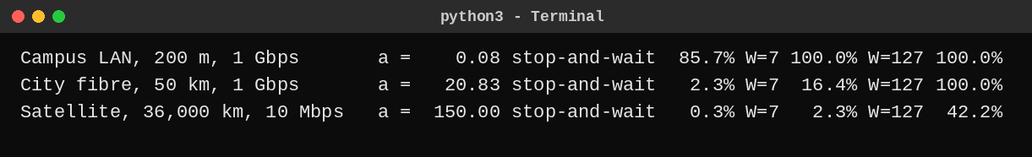

The output matches the expected output. Satellite link: a = 150, so the smallest window for 100% utilisation is 1 + 2a = 1 + 300 = 301 frames. (That is why W = 127 gives only 127 / 301 = 42.2%.)
Alternative Concept Analysis – Selective Repeat with a window of 64
Utilisation = 64 / (1 + 2a) = 64 / 334.33 = 19.1%
Throughput = 0.1914 × 1 Gbps = 191.4 Mbps, against about 1,000 Mbps with a window of 335
Receiver buffer = 64 × 1,500 B = 96 KB, against 502.5 KB for a window of 335; sequence numbers needed: 2^(n−1) ≥ 64, so n = 7 bits
A window of 64 saves about 406 KB of buffer and 3 sequence bits but wastes 81% of the link. The dedicated 1 Gbps line is paid for, so the window of 335 (Selective Repeat, 10-bit sequence numbers; in TCP terms a window of at least 500 KB with window scaling and selective acknowledgements) is the right choice.

ANSWER – TASK 10: Find Where the Delay Comes From
Propagation delay check
One-way propagation = 400 km / (2 × 10⁸ m/s) = 400,000 / 200,000,000 = 2 ms; round trip = 4 ms
Traceroute times are round-trip times, so I compare the final hop (12.6 ms) with 4 ms: propagation explains 4 / 12.6 = about 32% of the measured delay. The remaining 8.6 ms is queuing, serialisation, router processing and a fibre path that is longer than the straight 400 km. (If all 12.6 ms were propagation, the fibre path would have to be about 1,260 km each way, so the route is certainly not a straight 400 km cable.)
Delay added by each hop (median of the three probes)
Hop | Address | Probes (ms) | Median | Added by this hop
1 | 10.10.1.1 | 0.6, 0.5, 0.6 | 0.6 ms | +0.6 ms
2 | 100.64.0.1 | 3.1, 2.9, 3.4 | 3.1 ms | +2.5 ms
3 | 172.31.4.9 | 4.0, 38.2, 4.2 | 4.2 ms | +1.1 ms
4 | 103.21.8.17 | 11.8, 11.5, 12.1 | 11.8 ms | +7.6 ms (largest)
5 | * * * | no reply | – | unknown
6 | 10.200.0.10 | 12.6, 12.4, 12.9 | 12.6 ms | +0.8 ms (from hop 4)

- Hop 3 (one value of 38.2 ms): not a fault. The other two probes are 4.0 and 4.2 ms, and hops 4 and 6 behind it are normal. If the router were really slow at forwarding, every later hop would show the extra delay. A router answers traceroute with its slow control-plane CPU at low priority, so one reply can be late while the real traffic passes quickly.
- Hop 5 (stars): not a fault. The router there does not answer the TTL-expired probe (ICMP is blocked or rate-limited by a firewall or policy), but it clearly forwards packets, because hop 6 answers.
- The hop that adds the most delay is hop 4 (103.21.8.17): +7.6 ms, which is about 60% of the whole 12.6 ms. It is a public address, so it is the provider’s long-distance leg, and the 4 ms of fibre propagation lies inside this jump. Hop 2 (+2.5 ms) is second. The address 100.64.0.1 is in the carrier-grade NAT range, which shows that the current line is shared broadband, one more reason to use a leased line (Task 4).

Windows : tracert -d <server> ping -n 20 <server>
Linux : traceroute -n <server> ping -c 20 <server>
Wireshark capture filter: icmp or tcp port 443 (start capture, run ping, stop, then expand each header)

Layer | Header seen in Wireshark | What I read from it | Value in my capture
2 – Data link | Ethernet II | Source and destination MAC (the destination is my default gateway); Type 0x0800 = IPv4 | [fill in]
3 – Network | Internet Protocol v4 | Source and destination IP, TTL, Protocol 1 (ICMP) or 6 (TCP) | [fill in]
3 – Network (control) | ICMP | Type 8 echo request / type 0 echo reply; Time Exceeded (type 11) for traceroute | [fill in]
4 – Transport (web capture) | TCP | Source and destination port (443), sequence and acknowledgement numbers, flags | [fill in]

Alternative Concept Analysis – continuous monitoring versus occasional ping and traceroute
Problem seen above | Continuous monitoring (SNMP counters, NetFlow, regular probes) | Occasional ping / traceroute
Hop 3 one-off spike | A graph of router CPU and latency shows whether it repeats; found within one polling interval (1–5 min). An average can hide a very short spike. | Seen only if someone happens to run it at that moment, and one run cannot show whether it repeats.
Hop 5 stars | SNMP interface counters and NetFlow show that traffic is passing through, which proves it is not a fault (for devices the plant controls). | Only shows stars, which is ambiguous.
Hop 4 +7.6 ms (provider delay) | Probes every few seconds build a latency baseline and alert in seconds to minutes; SNMP shows congestion or drops at the plant’s own edge interface; NetFlow shows which traffic (for example CCTV) fills the link. SNMP cannot see inside the provider’s routers. | A snapshot with no baseline; found only when a user complains, which may be hours or days later.
Shared broadband (100.64.0.1) | Found when the network is documented; flow records show the actual path and loads. | Visible in the traceroute but needs a person to notice it.

ANSWER – TASK 11: Defend the Network Design
Recommended design
Area | Medium and settings | Error control / flow control | Numbers that justify it
Robot cells (85 m, near welders) | Cat6A S/FTP, shielded, 1000BASE-T, full duplex, auto-negotiation on at both ends; own VLAN with strict-priority queue | CRC-32 (FCS) detects; TCP retransmits; short link, a = 0.08, so a small window is enough (Task 9) | 32 Mbps per line (Task 1); capacity 1,257 Mbps even at 15 dB (Task 4); 70-byte frame is 82.9% overhead (Task 3)
CCTV cameras | Cat6 PoE to a line switch (under 100 m); motion-triggered recording | CRC; video tolerates loss, no retransmission | 96 Mbps continuous becomes 4.8 Mbps (Task 1)
Office floor (140 m) | Multimode fibre OM3 to the shop-floor switch; Wi-Fi 6 for office users | CRC + TCP | 140 m > 100 m copper limit (Task 4); 30 Mbps per line
Backbone shop floor ↔ data centre (550 m) | Single-mode fibre, 10 Gbps, full duplex | CRC + TCP | Plant traffic 1,265.92 Mbps > 1 Gbps (Task 1); 10G multimode reaches only 300–400 m
Sensors | Vibration sensors on Wi-Fi 6; slow temperature sensors on LoRaWAN | Hamming(21,16) FEC on the noisy radio link | LoRa cannot carry 240 kbps (limit 5 kbps) (Task 5); FEC 0.008 ms vs ARQ 0.65 ms (Task 8)
Moving equipment (AGVs) | Wi-Fi 6 with 802.11r (original design) | Wi-Fi retries | 39 hand-overs, 5.85 s unreachable per trip (Task 5), so this is flagged as a risk (see Task 12)
Head office (400 km) | Leased line, 1 Gbps with SLA (not ordinary broadband) | Selective Repeat, window 335, 10-bit sequence numbers (TCP window ≥ 500 KB) | a = 166.67; stop-and-wait gives only 2.99 Mbps (Task 9); traceroute shows 12.6 ms and shared 100.64.x broadband (Task 10)

The two biggest remaining risks
- Wireless for moving equipment. With Wi-Fi the AGV is unreachable for 39 × 150 ms = 5.85 s per trip (585 missed commands), and even 802.11r (about 1.95 s) cannot guarantee 10 ms. Mitigation: private 5G for mobile equipment (Task 12).
- Single points of failure and recovery time. One leased line and one backbone link can cut off the whole plant, and ring recovery of about 200 ms would lose about 20 robot commands. Welding noise (SNR 15 dB) can also push the error rate up if the shielding is poor. Mitigation: a second leased line, a redundant 10G backbone, PRP/HSR or a fast ring for the robot cells, and a noise measurement after installation.
Does the design still work for five plants?
 | 1 line | 1 plant (8 lines) | 5 plants
Devices | 40 | 1,500 | 7,500
Traffic, continuous CCTV | 158.24 Mbps | 1,265.92 Mbps | 6,329.6 Mbps
Traffic, motion-triggered CCTV | 67.04 Mbps | 536.32 Mbps | 2,681.6 Mbps

Yes, with changes that are already in the design. (1) Each plant keeps its own 10 Gbps core: 1,265.92 Mbps is only 12.7% of 10 Gbps. (2) Only summarised production data goes to the head office, and video is stored locally; streaming all CCTV would need 5 × 768 Mbps = 3.84 Gbps. (3) One 1 Gbps leased line per plant, each with a 335-frame window, and a 10 Gbps aggregation link at the head office. (4) 1,500 devices per plant need at least 6 VLANs of 254 hosts, so the plan uses a separate address block per plant and routing between sites. What does not scale is the Wi-Fi roaming for AGVs and any single 1 Gbps uplink.
Alternative Concept Analysis – whole plant on private 5G
Traffic (plant, 8 lines) | Volume | Carry on 5G? | Reason
Mobile equipment and AGVs | see Task 12 | Yes (URLLC) | Wired links cannot follow a moving vehicle, and 5G has only 3 hand-overs per trip.
Vibration sensors (4,800) | 1.92 Mbps | Yes (mMTC) | Tiny load but a huge number of devices, so wireless saves a lot of cabling.
CCTV continuous | 768 Mbps (60.7%) | No – cable (PoE and fibre) | 5G time-division duplex favours the downlink and its uplink is much smaller, so 768 Mbps of video would use up the cell. Motion clips (38.4 Mbps) could use 5G.
Fixed robot controllers | 256 Mbps | No – shielded cable | A cable gives a fixed latency with SNR 40 dB; 5G can be used only for robots that move or are reconfigured.
Office users | 240 Mbps | No – Wi-Fi 6 / cable | Cheaper per bit and no strict deadline.
Backbone to data centre | 1,265.92 Mbps | No – fibre | The 5G core and radios need fibre backhaul anyway.

So a split design is best: about 40 Mbps (sensors 1.92 + motion clips 38.4) plus the AGVs go on 5G, and about 1,000 Mbps or more (CCTV, office, fixed robots) stays on cable.

DAY-4 DESIGN CHALLENGE
ANSWER – TASK 12 A: Impact Analysis
Which parts of the original design are affected
Part of the design | Affected? | Why
Media | Yes, extended | The fibre backbone, Cat6A robot cells and fibre to the office stay. New fibre or PoE runs are needed for the 5G radio units (4 cells to cover the 1.2 km route) and the 5G core.
Wireless choices | Yes, changed | Wi-Fi 6 with 802.11r for AGVs is replaced by 5G URLLC; AGV cameras use an eMBB slice; Wi-Fi 6 stays for the offices.
Error-control settings | Yes, changed | AGV commands use 5G channel coding with fast HARQ instead of 802.11 retries; because a 40 ms retransmission is far beyond 10 ms, commands carry sequence numbers and are duplicated (dual connectivity). Wired links keep CRC-32 and TCP.

Traffic recalculated with 50 AGVs
The task does not give AGV traffic, so I assume for each AGV: a 200-byte control message every 10 ms (the deadline), which is 200 × 8 × 100 = 0.16 Mbps, plus 2 Mbps of camera and lidar telemetry. One AGV = 2.16 Mbps; 50 AGVs = 50 × 2.16 = 108 Mbps (control 8 Mbps, telemetry 100 Mbps), and 5,000 commands per second.
Plant traffic (8 lines) | Before | With 50 AGVs | Change
CCTV continuous | 1,265.92 Mbps | 1,373.92 Mbps (137% of 1 Gbps) | +108 Mbps (+8.5%)
CCTV motion-triggered | 536.32 Mbps | 644.32 Mbps (64% of 1 Gbps) | +108 Mbps (+20.1%)

The AGVs add only 7.9% of the volume (108 / 1,373.92) but carry the strictest deadline. With continuous CCTV the 1 Gbps uplink is overloaded even more, which confirms the 10 Gbps backbone chosen in Tasks 4 and 11.
ANSWER – TASK 12 B: Test the Original Design
The original design served AGVs with Wi-Fi 6, with access points 30 m apart (39 hand-overs of 150 ms on a 1.2 km, 600 s trip). Now there are 50 AGVs on the same route:
Per fleet trip (50 AGVs) | Original: Wi-Fi 6 | With 802.11r (assume 50 ms) | Private 5G
Hand-overs | 50 × 39 = 1,950 | 1,950 | 50 × 3 = 150
Unreachable time, total | 1,950 × 150 ms = 292.5 AGV-seconds | 1,950 × 50 ms = 97.5 AGV-seconds | 150 × 20 ms = 3 AGV-seconds
Per AGV | 5.85 s | 1.95 s | 0.06 s
Commands missed (10 ms each) | 1,950 × 15 = 29,250 | 1,950 × 5 = 9,750 | 150 × 2 = 300

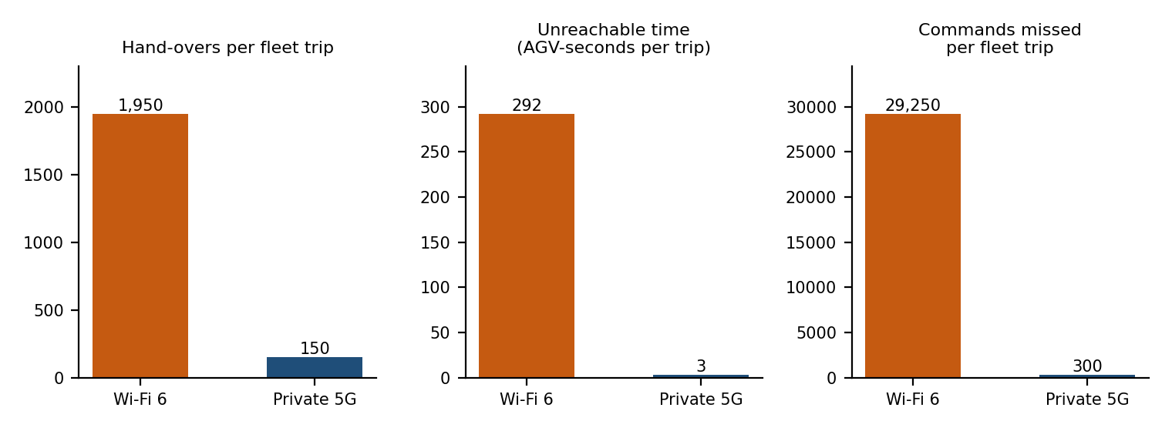
Figure 3 – Wi-Fi 6 against private 5G for 50 AGVs on one 1.2 km trip
Result of the test: the original design fails. On average 292.5 / 600 = 0.49 AGV is in the middle of a hand-over at every moment, so almost always one vehicle somewhere cannot be reached, and each AGV misses 585 commands per trip, although the requirement is that it must never miss a command. Capacity is not the problem (50 AGVs × 2.16 Mbps over 40 access points is tiny); mobility is. The wired parts of the design (robot cells, backbone, WAN) are not affected by the change and still pass their tests.
ANSWER – TASK 12 C: Adaptation or Redesign
Decision: MODIFY. I keep everything that already passes its test and replace only the part that fails (wireless for moving equipment).
Area | Revised design
AGVs and mobile robots | Private 5G with a URLLC slice. 4 radio cells (300 m each) along the 1.2 km route give 3 hand-overs of 20 ms; dual connectivity (or conditional hand-over) removes the remaining gap. A 5G core with a local user plane inside the plant keeps latency below 10 ms. AGV traffic is marked DSCP EF and given strict priority on the switches.
AGV cameras and lidar | 5G eMBB slice (about 100 Mbps in total).
Sensors | 5G mMTC or Wi-Fi 6 for the 600 vibration sensors; LoRaWAN for slow sensors (unchanged logic from Task 5).
Fixed robot cells | Unchanged: Cat6A S/FTP, full duplex, VLAN with priority, ring with fast recovery or PRP/HSR.
Offices | Unchanged: Wi-Fi 6 (offices only), multimode fibre for the 140 m run.
Backbone and WAN | Single-mode fibre at 10 Gbps (1,373.92 Mbps is 13.7% of it), fibre or PoE backhaul to the 5G radios, leased line to the head office with Selective Repeat window 335.
Error control for AGV commands | 5G channel coding and HARQ, plus application sequence numbers and duplicated commands; no 40 ms end-to-end retransmission.

ANSWER – TASK 12 D: Evidence-Based Defence
Measure (50 AGVs, one trip) | Original (Wi-Fi 6) | Modified (private 5G) | Improvement
Hand-overs per AGV | 39 | 3 | 13 times fewer
Unreachable time per AGV | 5.85 s | 0.06 s | 97.5 times less
Commands missed per AGV | 585 | 6 (target 0 with dual connectivity) | 97.5 times fewer
Commands missed by the fleet | 29,250 | 300 | 97.5 times fewer
Backbone load | 1,373.92 Mbps (137% of 1 Gbps) | 13.7% of 10 Gbps | Fits with room to grow

Why MODIFY is the right decision. Retaining the design is not possible because the Wi-Fi design misses 585 commands per AGV, but a full redesign is not needed because the wired parts already meet their requirements: the shielded robot cable has a Shannon capacity of 3,322 Mbps against 32 Mbps used, and the backbone has room. Putting the whole plant on 5G would put 1,265.92 Mbps in the air, and 768 Mbps of that is CCTV uplink (Task 11), which a cell cannot carry. Changing only the mobile part gives about 97 times less outage for the smallest change.
Trade-offs and remaining risks.
- Cost and effort: 5G radios, a local core, spectrum (a licence or operator lease), 5G modules in the AGVs and trained staff cost more than adding Wi-Fi access points.
- 20 ms hand-over is still more than 10 ms: without dual connectivity each hand-over still loses 2 commands (6 per AGV), so this feature is required, not optional.
- Coverage assumption: the 300 m cell is a planning figure; inside a metal building it may be only 100 m. Then there would be 12 cells and 11 hand-overs, or 11 × 20 ms = 0.22 s per trip, which is still about 27 times better than Wi-Fi (5.85 s). A site survey must confirm this before purchase.
- Assumed AGV traffic: if telemetry is higher than 2 Mbps per AGV, the eMBB slice and backbone must be re-checked; the backbone has room for more than 8 Gbps of growth.

